**Orthographic Projection of Lines/Planes**

1. A line AB, inclined at 40° to the V.P., has its ends 50 mm and 20 mm above the H.P. The length of its front view is 65 mm and its V.T. is 10 mm above the H.P. Determine the true length of AB, its inclination with the H.P. and its H.T.

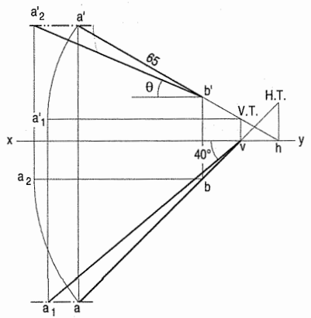

2. The projectors of the ends of a line AB are 50 mm apart. The end A is 20 mm above the H.P. and 30 mm in front of the V.P. The end B is 10 mm below the H.P. and 40 mm behind the V.P. Determine the true length and traces of AB, and its inclinations with the two planes.

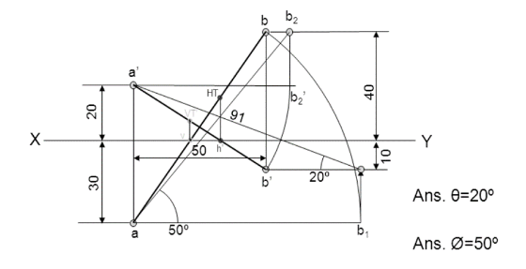

3. A straight road going uphill from a point A, due east to another point B, is 4 km long and has a slope of 15°. Another straight road from B, due 30° east of north, to a point C is also 4 km long has zero slope. Determine the length and slope of the straight road joining the points A and C. Scale, 10 mm = 0.4 km.

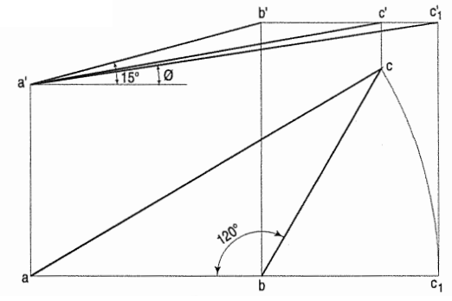

4. Two lines AB and AC make an angle of ·120° between them in their front view and top view. AB is parallel to both the H.P. and the V.P. Determine the real angle between AB and AC. Assume any length for the final front view and the final top view of the two lines.

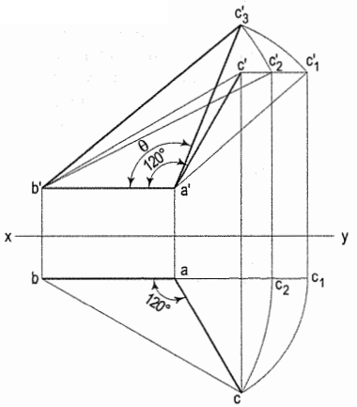

5. PQRS is a rhombus having diagonal PR = 60 mm and QS = 40 mm and they are perpendicular to each other. The plane of the rhombus is inclined with H.P. such that its top view appears to be square. The top view of PR makes 30° with the V.P. Draw its projections and determine inclination of the plane with the H.P.

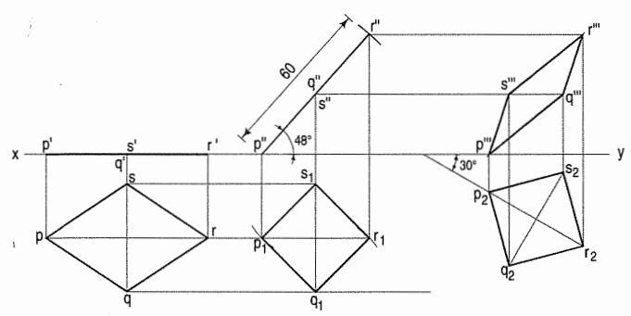

6. Draw the projections of a circle of 75 mm diameter having the end A of the diameter AB in the H.P., the end B in the V.P., and the surface inclined at 30° to the H.P. and at 60° to the V.P.

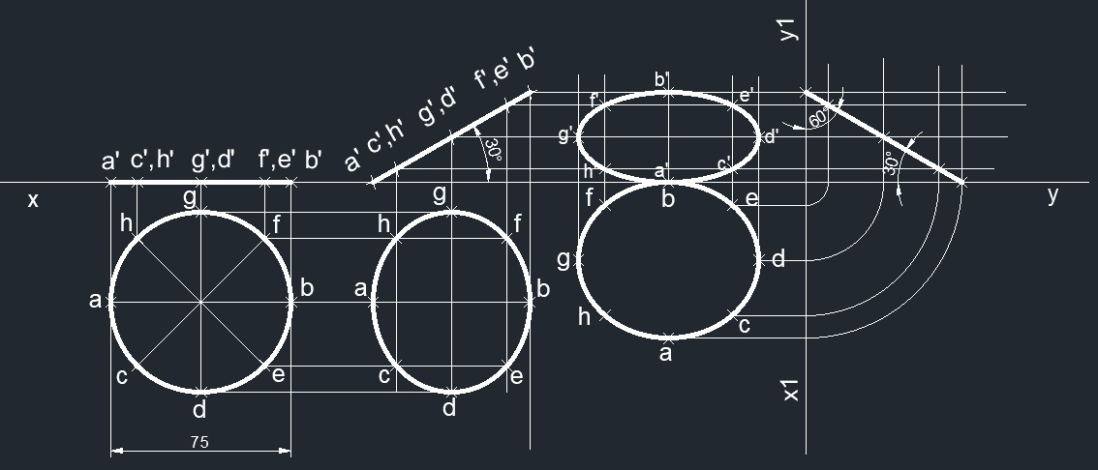

7. An isosceles triangle of 40 mm long base side, 60 mm long altitude is freely suspended from one corner of base side. Its plane is inclined at 45°to VP. Draw its projections.

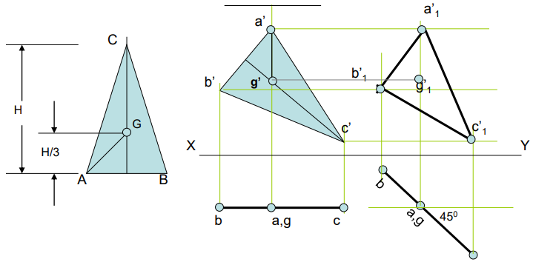

8. A rhombus of diagonals 40 mm and 70 mm long respectively has one end of its longer diagonal in H.P. while the same diagonal is inclined at 45° to the H.P. and makes 30° with the V.P. Draw its projections.

